PIVOT 2 kick off meeting official invitation

Dear Partners,
You all invited to PIVOT 2 kick off meeting, hosted by Faiveley Italy, in Piossasco.

Save the date: 16th and 17th October.

Only for brakes partners: 15th October, brakes kick off.

Faiveley Italy
Piossasco Via Volvera 51, Piossasco, Torino

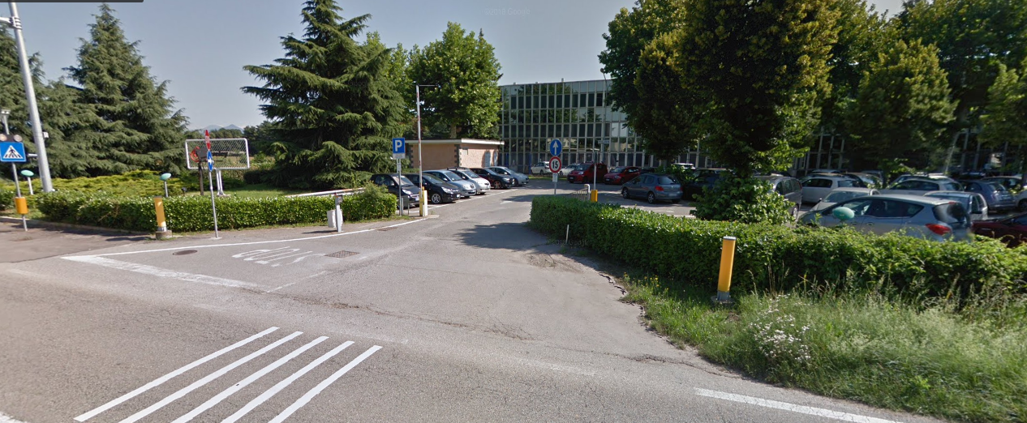

Hotel very close to our plant in Piossasco (5 minutes by car)

- Hotel San Giorgio (nearly 60€ per night) http://www.anticoborgodisanvito.com/trattoria-san-giorgio/

- Villa Mirano b&b (nearly 60€ per night)http://www.villamirano.it/it/

Turin center - Hotel suggestions close to train station, city center and bus line

- Hotel Vinzaglio http://www.booking.com/Share-k4Ehy9b
- Hotel Eden http://www.booking.com/Share-Iz6BUeE
- Hotel Best Western Piemontese http://www.booking.com/Share-Ab1SLF

How to reach us

From Turin Caselle Airport – By car

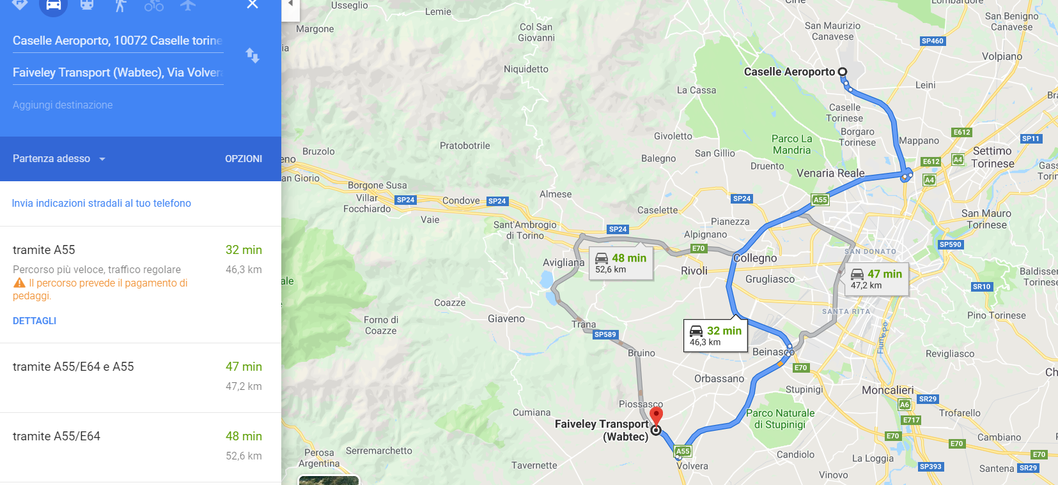

From Milano Malpensa Airport - By car

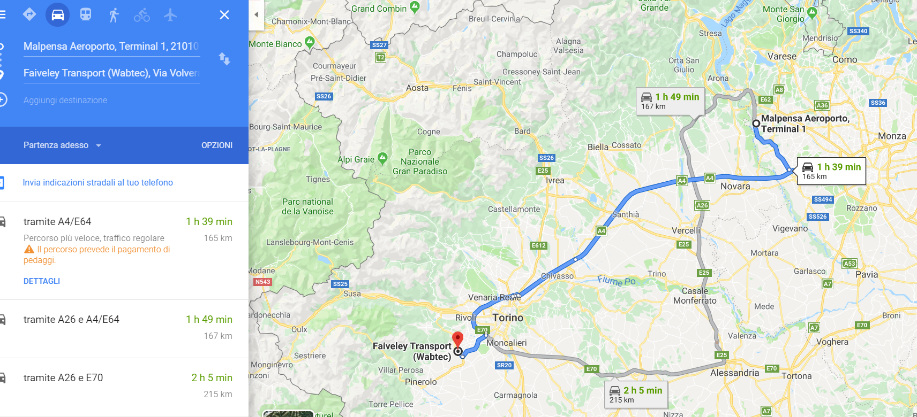

From Milano Malpensa Airport - By Bus
http://www.sadem.it/it/prodotti/collegamento-aeroporti/torino-milano-malpensa.aspx
https://www.flixbus.it/tratte-autobus/torino-milano-malpensa-aeroporto

From Milano Malpensa Airport - By train
https://www.malpensashuttle.it/
https://www.trenitalia.com/ from Milano centrale to Torino Porta Nuova / or Torino Porta Susa

Connection from Turin city center to Faiveley
GTT – Line 1085 – bus stop « P.I.P »
http://www.gtt.to.it/cms/percorari/urbano?view=percorsi&bacino=E&linea=1085

